# Sales Catalogue

# Search Module

Table of Contents

Sales Catalogue 1

Search Module 1

1.0 How to search product data? 3

1.1.0 Login to Sales Catalogue application 3

1.2.0 Menu navigation 3

1.3.0 Selection of Product/Country 3

1.4.0 Locating data 4

2.0 Contact Us: 9

# 1.0 How to search product data?

## 1.1.0 Login to Sales Catalogue application

To access Sales Catalouge application <http://sc.intra.bt.com/prodcat22_sm> address to be used in browser and login by entering BT UIN and iUSER password.

## 1.2.0 Menu navigation

For new Search Module menu navigation is Search -> Product Availability as shown below.

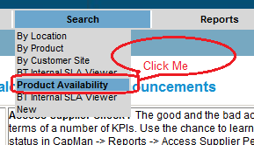

On click of ‘Product Availability’ search is launched in new window as below, where the previous functionality ‘Search By Product’ and ‘Search By Location’ has been merged.

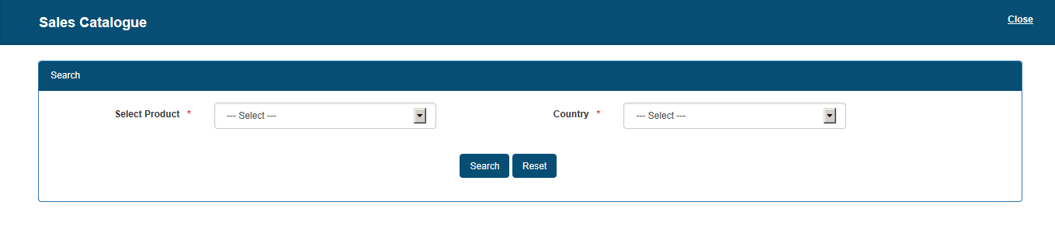

## 1.3.0 Selection of Product/Country

On Selection of a particular product (BT MPLS) the country associated with it would be filtered in the Country drop-down.

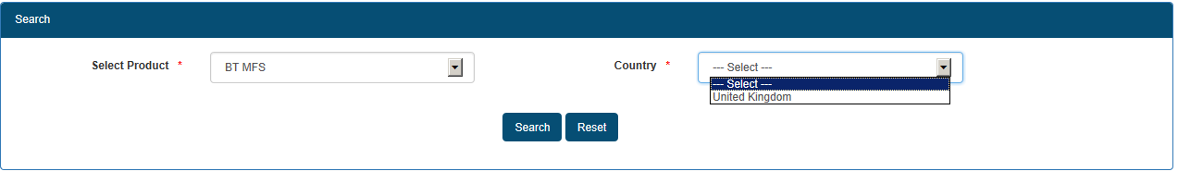

Vice Versa on selection of Country (Tonga) the products valid for that country would be filtered out in Select Product drop-down.

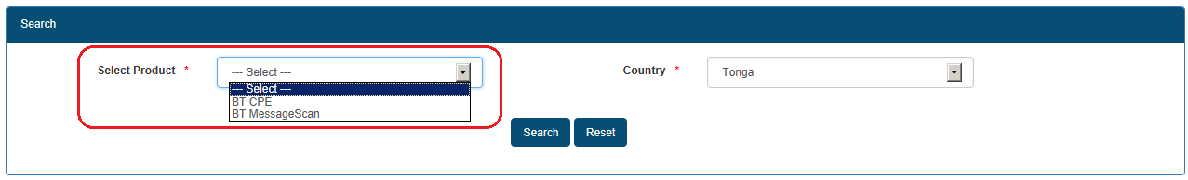

If any other filter has to be selected then ‘Reset’ button is to be clicked.

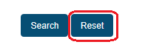

## 1.4.0 Locating data

#### 1.4.1 Access

Under Select Product, select product as ‘Access’ and ‘Country’ as Australia for e.g. Click on Search button.

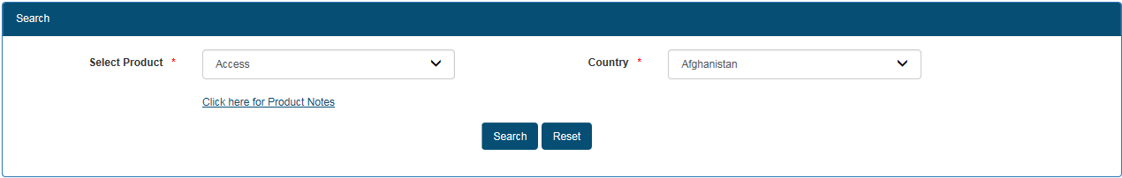

Filter with State/Province, City and PoP would be populated with list of values w.r.t the search performed.

On selection of PoP (Sydney, The Broadway), State/Province and City populates.

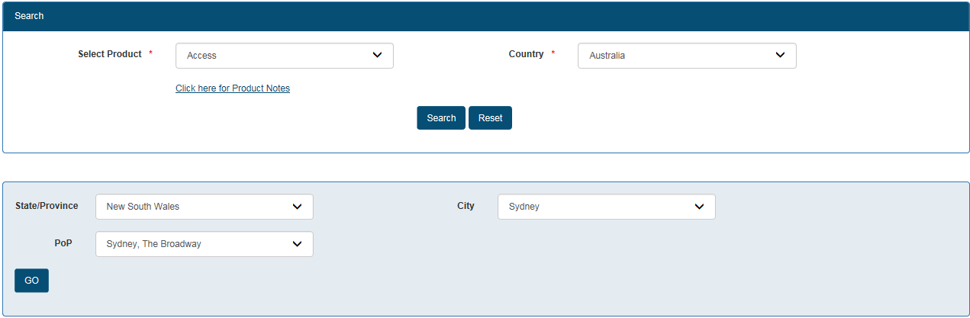

Click of ‘Go’ Access related details for the search performed would be visible in the same page.

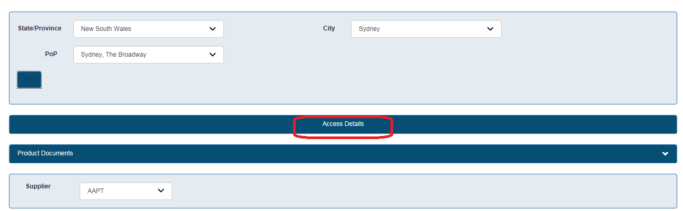

Product Documents would be visible as a tab and on click of the collapsible link documents would be visible.



Click of the collapsible icon



List of supplier’s available would be listed as below, on change of supplier the data would be reflected accordingly in the grid.

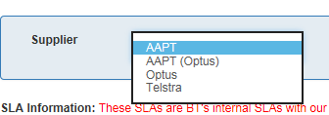

Supplier specific data would be displayed under column’s **Speeds, Access Type, Supplier Product Name/BT Internal SLA Information and Access Display Interface** as below.

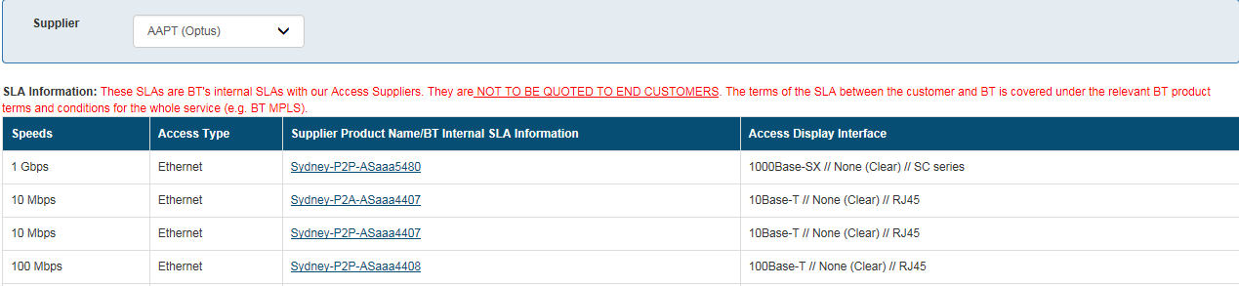

#### 1.4.2 BT CPE

On selection of BT CPE product, system will ask for Country and City values to be selected.

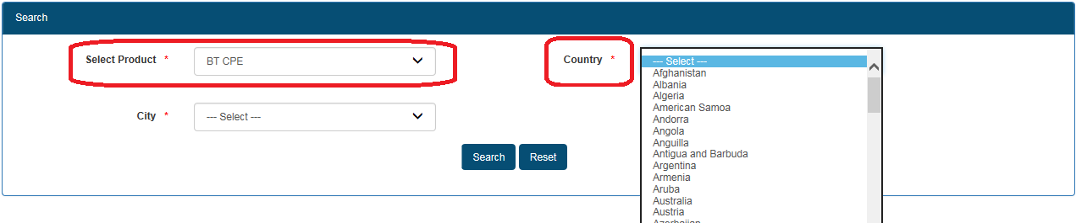

For example, select Country : Australia and City : Sydney.

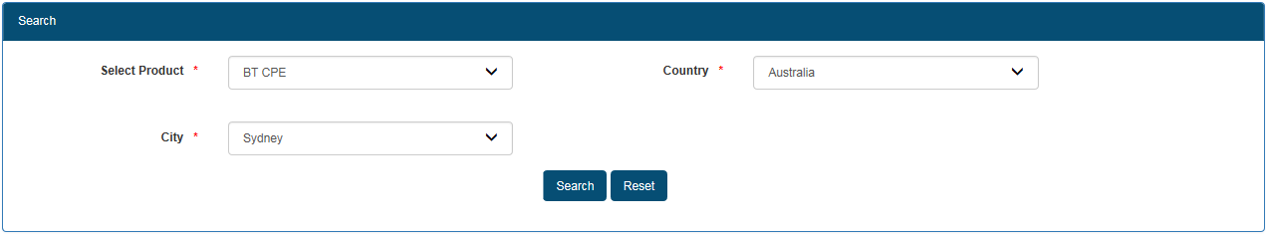

On Click of Search, BT CPE Details would be displayed below in the same page.

By default data would be displayed for ‘ALL’ suppliers and list of supplier would be displayed as below.

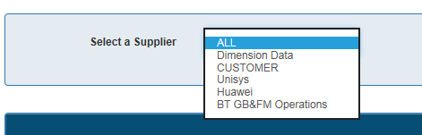

On selection of supplier the CPE data would be filtered in the search screen.

##### Maintenance Option

On click of product name, MO’s of a product are visualised.

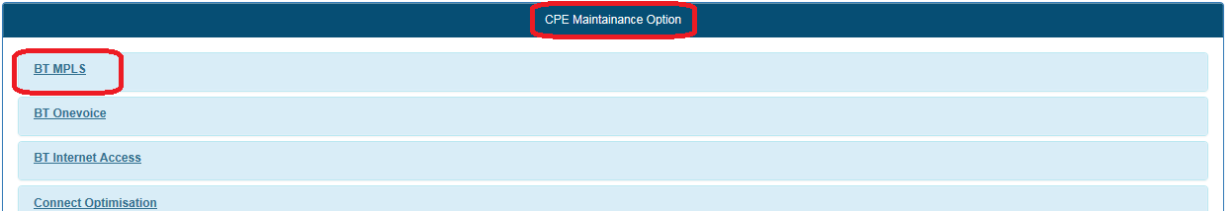

For e.g Click BT MPLS

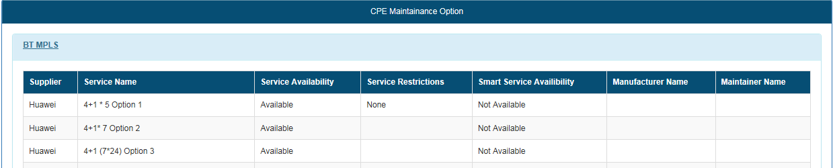

##### CPE Bundles

System behaves in similar manner to ‘Maintenance Option’. On click of product name all Bundle related data is seen. For each Bundle , ‘Parts’ link is enabled which would be shown as below.

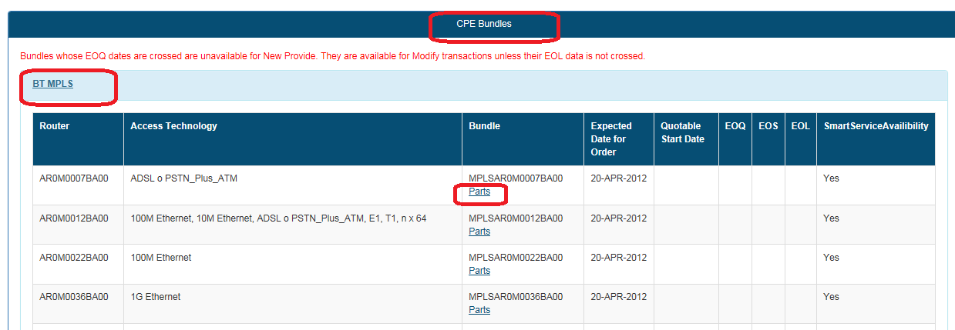

On click of parts link, new window with Standard Parts, Variable Parts, etc would be displayed.

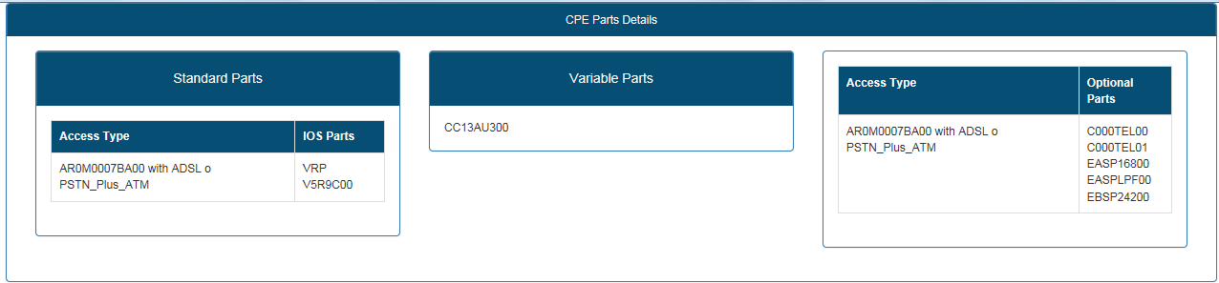

#### 1.4.3 Products like MPLS Capability, Etherflow Capability.

On selection of Product e.g MPLS Capability and Country Australia the page would be as below:

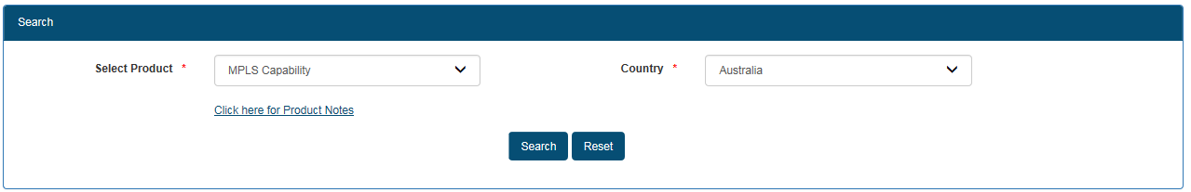

##### Common Point 1 – Tab Menus

Click of Search, page would be displaying menu tab’s like ‘Eth/LL’, ‘hVPN’, ‘DSL’, ‘VSAT’ and ‘Product Documents’. If any product document’s/link are applicable then, ‘Product Document’ tab would be enabled.

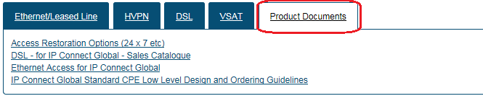

##### Common Point 2 – Ethernet/LeasedLine

On click of Ethernet/LeasedLine, PoP, City and State/Province would be populating. On selection of PoP(Bremen), as applicable State/Province and City would be populating.

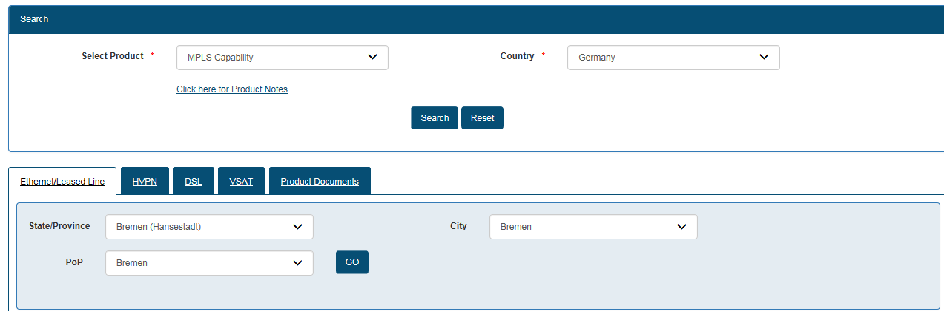

Click of Go PoP and Product details to be displayed.

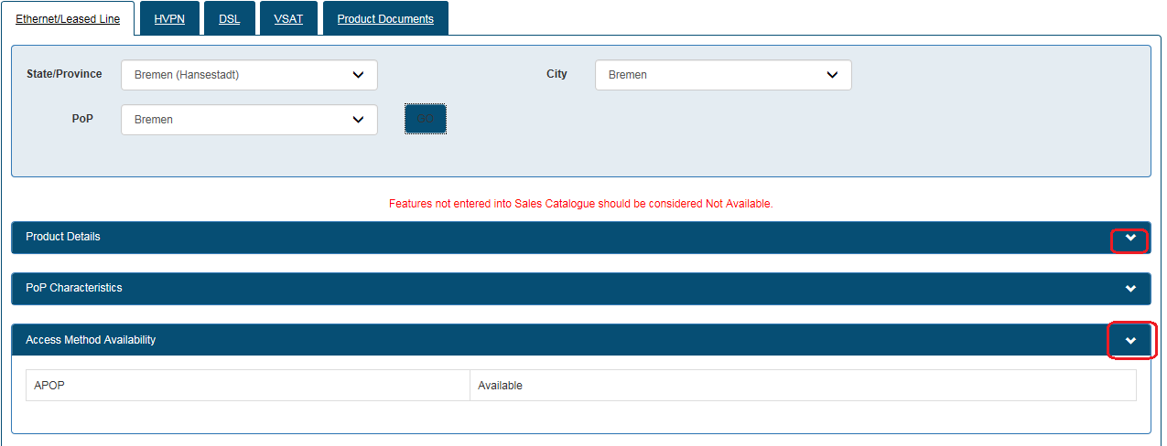

Below these details filters **Access Supplier, Port Speed, Access Speed(s), Access Supplier Products and Access Type** are to be selected and ‘Go’ is to be clicked.

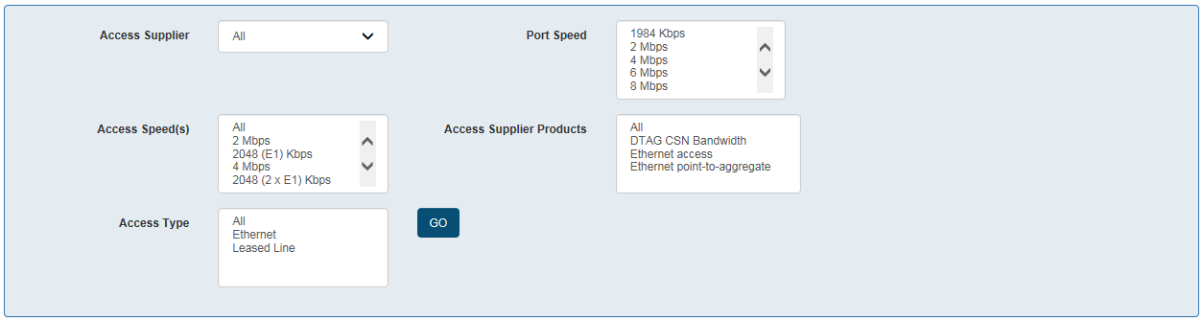

Port Speed selection among these filter’s is mandatory. For e.g. select

#### 1.4.4 Products like BT iVPN, BT iVPN,BT Etherflow Global,etc

#### 1.4.5 Products like BT One Voice, ICG, etc

#### 1.4.6 Products like BT Bandwidth Services, BT LAN SAN extension Service, etc

#### 1.4.7 BT Internal SLA Viewer

## 2.0 Contact Us:

Case of any queries related to usage of Search please free to contact us on –

* [sc_support@virtusa.com](mailto:sc_support@virtusa.com)
* Mayuri Bagi ([mayuri.bagi@bt.com](mailto:mayuri.bagi@bt.com))
* Ravi Tokas ([ravi.tokas@bt.com](mailto:ravi.tokas@bt.com) )